(Approx. 689 words)

Tech Magazines, now Websites
By Dick Maybach, Brookdale Computer User Group
www.bcug.com
n2nd (at) att.net

When PCs arrived in the 80s, bookstores were full of hobbyist magazines, such as PC Magazine, PC World, and Dr. Dobbs Journal. Now, most PC users consider their devices to be appliances rather than hobby equipment, and magazines have disappeared. However, a few enthusiasts remain, as do publications that support them, but most now as websites. These are not where you go to find problem solutions but to learn about new developments and tutorials. Here are a few examples.

PC Magazine appeared once or twice a month in my mailbox, and I would read every page. It now is a website, https://www.pcmag.com/, that covers Macs and PCs.

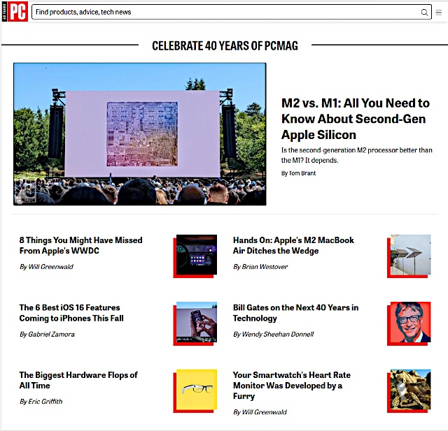

The website covers more topics than its print predecessor and includes product, advice, and tech news reports. There is a search feature to help you find past articles that interest you. As with all websites, the content evolves continually, so if you see something interesting, you may wish to save the article or its URL. In addition, you can subscribe to special-topic newsletters (what’s new, lab reports, tips, tricks, etc.), apparently at no cost.

PC World is also still alive and well, https://www.pcworld.com/.

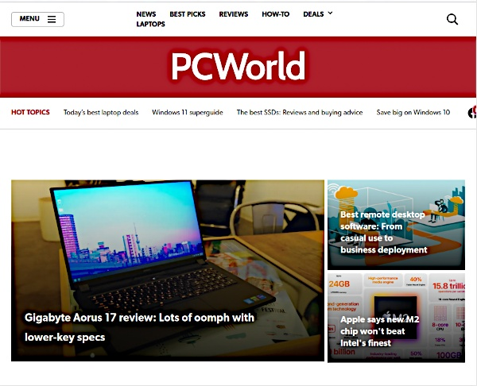

The topics are less wide-ranging than those on the PC Magazine site and are mainly limited to PCs. However, they also have free newsletters, and you can subscribe to their digital magazine for about $20 per year to relive the print magazine experience.

Another old favorite was ComputerWorld, https://www.computerworld.com/.

They, too, have free newsletters on specific topics, and the site is searchable.
See Tom’s Hardware, https://www.tomshardware.com/, for information on PC components. Unfortunately, this never appeared in print and is formatted as a traditional website rather than a periodical.

You’ll find detailed reviews of motherboards, CPUs, monitors, storage devices, other peripherals, and complete computers here. There are also tutorials on building and testing PCs and forums where you can ask questions and exchange views. Although the name implies, this is a one-person project, a sizable staff supports the site.

If you’re looking for tutorials or help to solve PC problems, check Computer Hope, https://www.computerhope.com/tips/index.htm. Unfortunately, this, too, has existed only as a website.
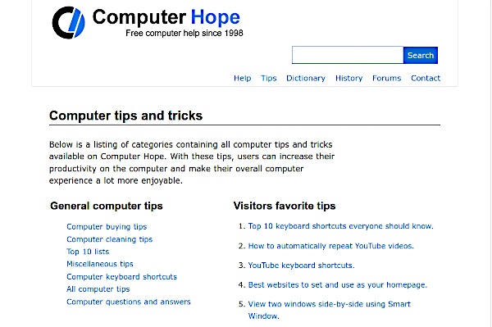
If you need information or help on specific topics, this may be a better site than the general-information ones above. In addition, its coverage includes Linux, while the first three above appear to be limited to Windows and Macs.

Full Circle Magazine, http://fullcirclemagazine.org/, is a 60 to 70-page monthly publication covering primarily Ubuntu Linux, although much of the material has a wider scope.

Unlike the sites discussed above, this magazine began publication in 2007 and continues today. You can read or download the issues online as PDFs or EPUB files. The monthly issues cover Ubuntu primarily, but

There are also special issues on such topics as the Python language and LibreOffice. But, like print magazines, once an issue is published, it doesn’t change.

Raspberry Pi users have MagPi, https://magpi.raspberrypi.com/, a 100-page monthly, available as a download or in print.

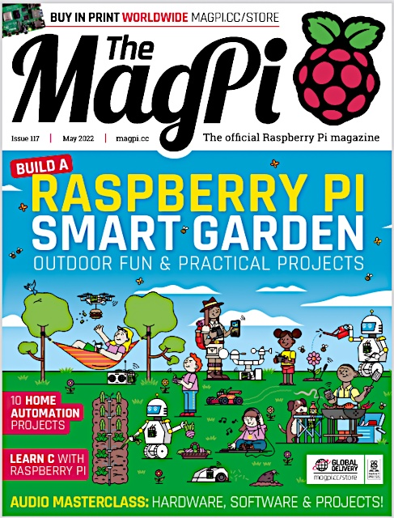

The first issue was published in 2012. Like Full Circle, you can read and download the issues for free, although they request a donation. Many articles describe hardware and software projects, often with a link to step-by-step instructions. This is an essential resource if you are working with a Raspberry Pi.

Arduino users should check the blog on the Arduino website, https://blog.arduino.cc/.

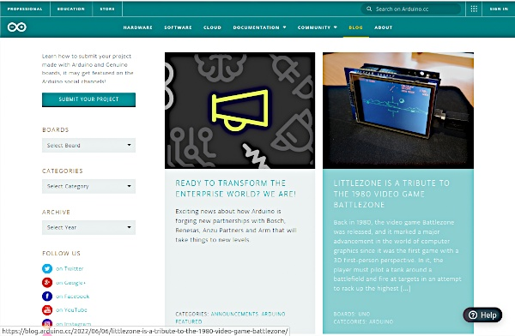

This blog, not a magazine, is made of short articles describing Arduino projects with links to more complete descriptions. Since the content changes continually, you’ll want to record the URLs of those that interest you.

This has been a sampling of some resources available to those interested in PCs, and many more may suit you better. With the decline of printed publications, it’s easy to use the Internet only to find solutions to specific problems, which can narrow our focus. However, in the early days of PCs, print magazines continually exposed us to new products and ideas, which websites like those discussed here can do today. PCs are wonderful aids for exploring and growth; losing this resource would be a shame.

